**A**

**PROJECT REPORT**

**ON**

**TASK MANAGEMENT SYSTEM**

BACHELOR’S OF SCIENCE

IN

COMPUTER SCIENCE

**SUBMITTED BY**

**RUGVED HINUKALE**



**S.K. COLLEGE OF SCIENCE AND COMMERCE,**

**PLOT NO.31, SEC.25, SEAWOODS , NAVI MUMBAI – 400706**

**2024-25**

**A**

**PROJECT REPORT**

**ON**

**TASK MANAGEMENT SYSTEM**

BACHELOR’S OF SCIENCE

IN

COMPUTER SCIENCE

**SUBMITTED BY**

**RUGVED HINUKALE**

PROJECT GUIDE

MRS. WINSHINY

**S.K. COLLEGE OF SCIENCE AND COMMERCE,**

**PLOT NO.31, SEC.25, SEAWOODS , NAVI MUMBAI - 400706**

**2024-25**

**ABSTRACT**

TASK MANAGEMENTSYSTEM developed to improve the efficiency of task allocation, tracking, and completion within teams and organisations. The system offers key functionalities such as task creation, assignment, prioritisation, and deadline management through a user-friendly and intuitive interface. By addressing common challenges in task management, such as poor communication and missed deadlines, the system aims to enhance overall productivity.

The Task Management System supports different user roles, allowing for customised access and permissions. It is designed with scalability and flexibility in mind, making it suitable for various organisational sizes and structures. The system's architecture utilises modern web technologies, ensuring it is secure, reliable, and easy to maintain. By automating and organising the task management process, the system helps users focus on their priorities, thereby improving workflow efficiency and reducing the chances of error.

This project involved the analysis of existing task management tools, identifying their limitations, and developing a solution that meets the practical needs of users. The result is a robust, efficient, and adaptable Task Management System that can be easily integrated into different organisational environments**.**

**ACKNOWLEDGEMENT**

I would like to express my special thanks of gratitude to my project guide **MRS WINSHINY** for their guidelines and support in making my project successful.

I am very thankful to our principal **DR SWATI VITKAR**  for their kind cooperation in completion of my project.

I am also grateful to **MRS VRUSHALI GHATPANDE**  , head of department for being very much resourceful, kind and helpful. And also thankful for their positive attitude, time and efforts she provided to us. Your useful advices gives us confidence to do project successfully.

I also wish to thanks our lab assistant and all my friends and entire **computer department** who helped me in completion of my project.

Last but not the list I would like to thank my family without whose support , motivation and encouragement it would not have been possible.

**PREFACE**

It gives me great pleasure to present the project on “**TASK MANAGEMENT SYSTEM**” prepared sincerely, punctually and with utmost efforts.

The contents of this book are presented into many chapters, in order to ease reading. The project has been illustrated with precise data elucidated with precise data elucidated with neat Use Case Diagram and Activity Diagram that simplify the understanding of the project. The project includes the software development tools like Apache, PHP, MYSQL.

Meticulous care has been taken to make this project perfect and useful in every respect.

**RUGVED HINUKALE**

**DECLARATION**

I the undersigned **Mr. RUGVED HINUKALE** hereby, declare that the work embodied in this project work titled **“TASK MANAGEMENT SYSTEM”** forms my own contribution to the research work carried out under the guidance of **MRS. WINSHINY**  is a result of my own research work and has not been previously submitted to any other University for any other Degree/ Diploma to this or any other University.

Wherever reference has been made to previous works of others, it has been clearly indicated as such and included in the bibliography.

I will abide and take all responsibility of all issues related to plagiarism/self-plagiarism mentioned under UNIVERSITY GRANTS COMMISSION (PROMOTION OF ACADEMIC INTEGRITY AND PREVENTION OF PLAGARISM IN HIGHER EDUCATIONAL INSTITUTIONS) REGULATIONS, 2021.

I, here by further declare that all information of this document has been obtained and presented in accordance with academic rules and ethical conduct.

Submitted by Certified by

**RUGVED HINUKALE**

**INDEX**

|  |  |
| --- | --- |
| INDEX | TOPIC |
| 1 | **PRELIMINARY INVERTIGATION** |
|  | i. INTRODUCTION |
|  | ii. DEVELOPMENT TOOLS |
|  | iii. FEATURES |
|  | iv. LIMITATIONS |
|  | v. DESCRIPTIONS SYSTEM |
| 2 | **SYSTEM REQUIREMENTS** |
|  | i. SOFTWARE REQUIREMENTS |
|  | ii. HARDWARE REUIREMENRTS |
| 3 | **SYSTEM ANALYSIS** |
|  | I . ER DIAGRAM |
| 4 | **SYSTEM CODING** |
|  | i. VALIDATION CODE |
|  | ii. DATA SET |
| 5 | **SYSTEM DESIGN** |
| 6 | **FUTURE ENHANCEMENT** |
| 7 | **CONCLUSION** |
| 8 | **REFERENCES AND BIBLIOGRAPHY** |

1. **PRELIMINARY INVERTIGATION**

**INTRODUCTION**

“Task management System” it is a user friendly application. It manages all the information related to the task and projects. It includes their staffs their assigned tasks, when any new employee comes then admin can add them to their portal. Only admin have the authority to do all the changes in the data. So the data in the databases is totally secure .

Admin have to fill the correct login email-id and password to get entered into the dashboard. Here you can also check your tasks reports and projects. Every employee has a unique employee id and passwords. Admin can update the details of both another admin and employee’s. In the about session you will get all the details like email and about info.

This is a user friendly as well as safe application . it provides full security to the data stored in the database.

**DEVELOPMENT TOOLS**

**FRONT-END :** PHP

**BACK-END :** PHP **,**MYSQL Workbench(Database)

**OPERATING SYSTEM :** Windows 11

**FEATURES**

1. New information can get added easily.
2. Admin can easily operate the system.
3. It gives you full of security .
4. It is a user friendly application.
5. Tasks details of any employee or project manager we can retrieve easily.
6. Status related information about tasks and project can be easily known to all admin’s.
7. Overall application is useful.

**LIMITATIONS**

* Only admin can do any changes in the data.
* Employee or team members cannot change status of tasks and project.
* No any employee can make any changes in assigned work.
* No time management features.
* No reminders about deadlines

**DESCRIPTION OF THE SYSTEM**

**TASK MANAGEMENT SYSTEM,**  is a desktop based application . task management system is all related to managing the whole staff and all admins. It helps you to keep all the data stored so that when you want it you can recover it easily .

Key Features:

1. Use MYSQL database which is one of the best database.
2. Use of password protection.
3. All data can get entered easily.
4. It helps organizations to keep their data private and stored for long.
5. It gives the information related to tasks status.
6. It can give you can data easily in reports sections.

The Task Management System aims to increase productivity by reducing the chaos of managing tasks through multiple channels such as emails, spreadsheets, or verbal communication. By providing a single platform for task management, it improves organization, accountability, and transparency within teams. It is too much useful for all. Managing tasks includes designations of staff their assigned project , all the data stored in the mysql database. It is one of the most popular database to storer the data. It is secure because only admin can log into this

1. **SYSTEM REQUIREMENTS**
2. **SOFTWARE REQUIREMENTS**

* Apache Xampp
* Any operating system

1. **HARDWARE REUIREMENRTS**

* Any laptop or PC with specific software.

1. **SYSTEM ANALYSIS**

**1.ERDiagram**

1. **SYSTEM DESIGN**

1.Login page

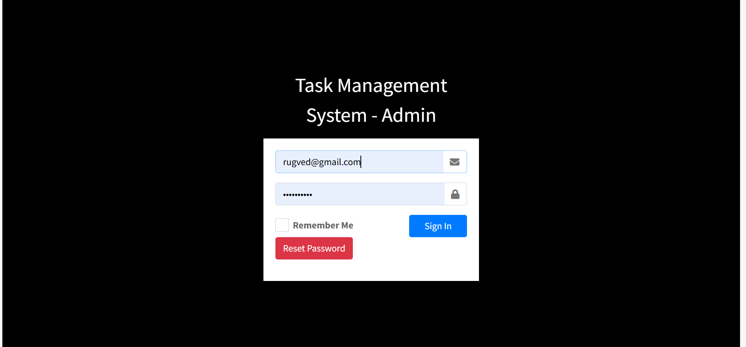

2. Home Page(Admin)

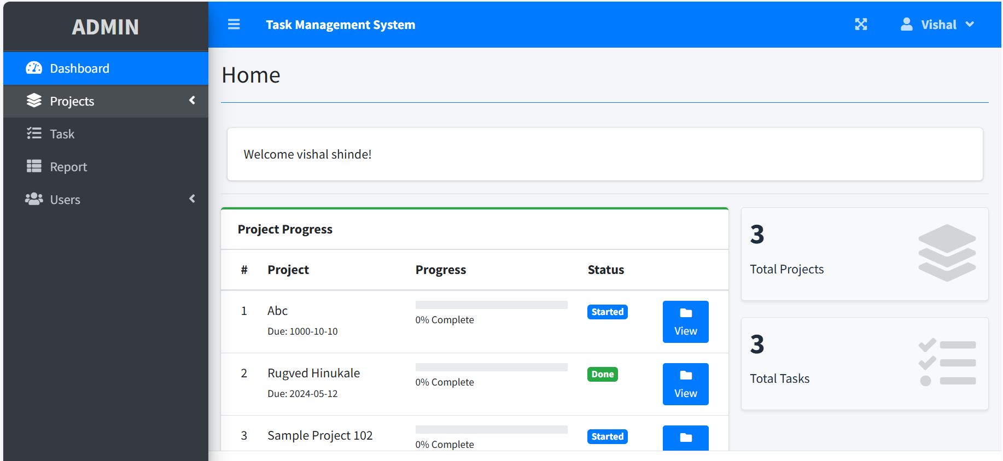

3.For assigning new projects.

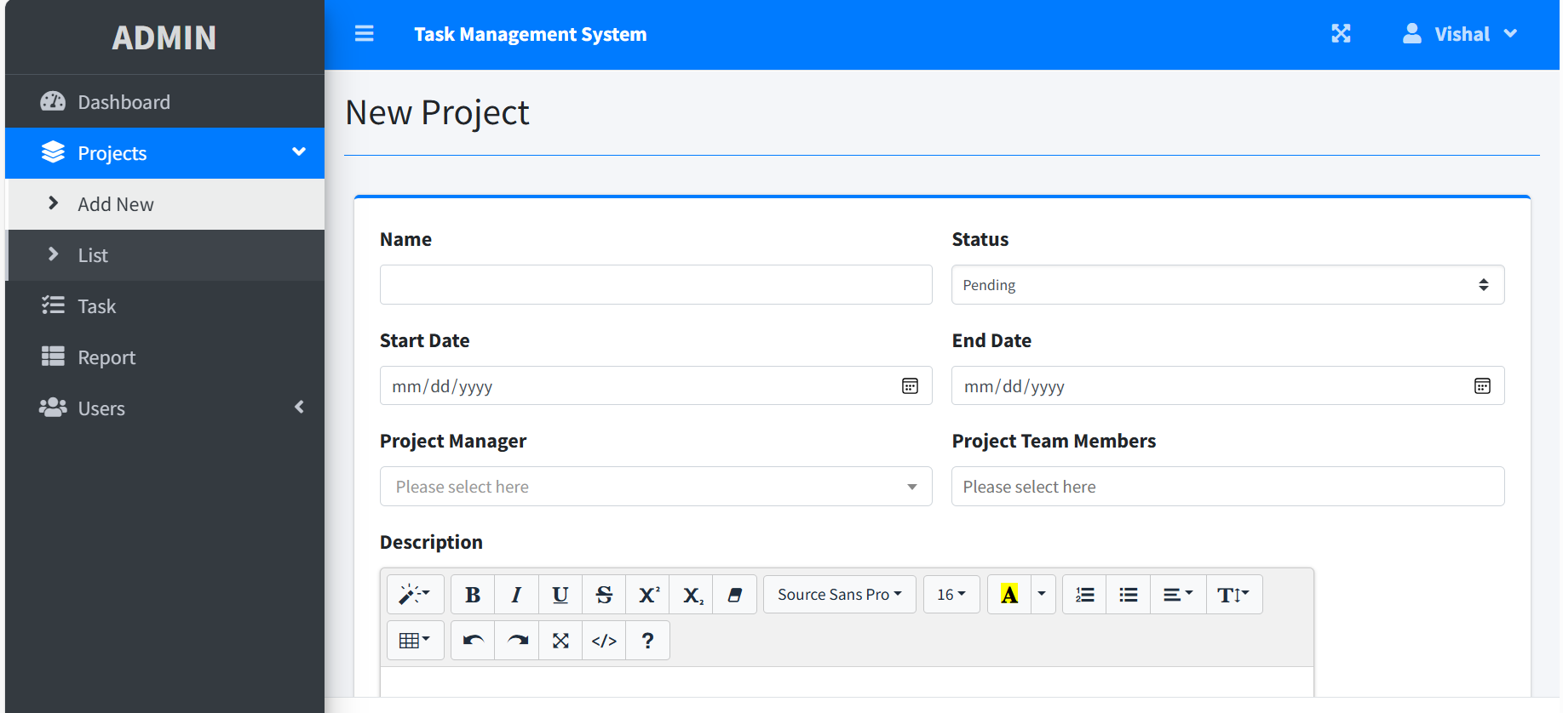

4.For viewing information list of all assigned projects.

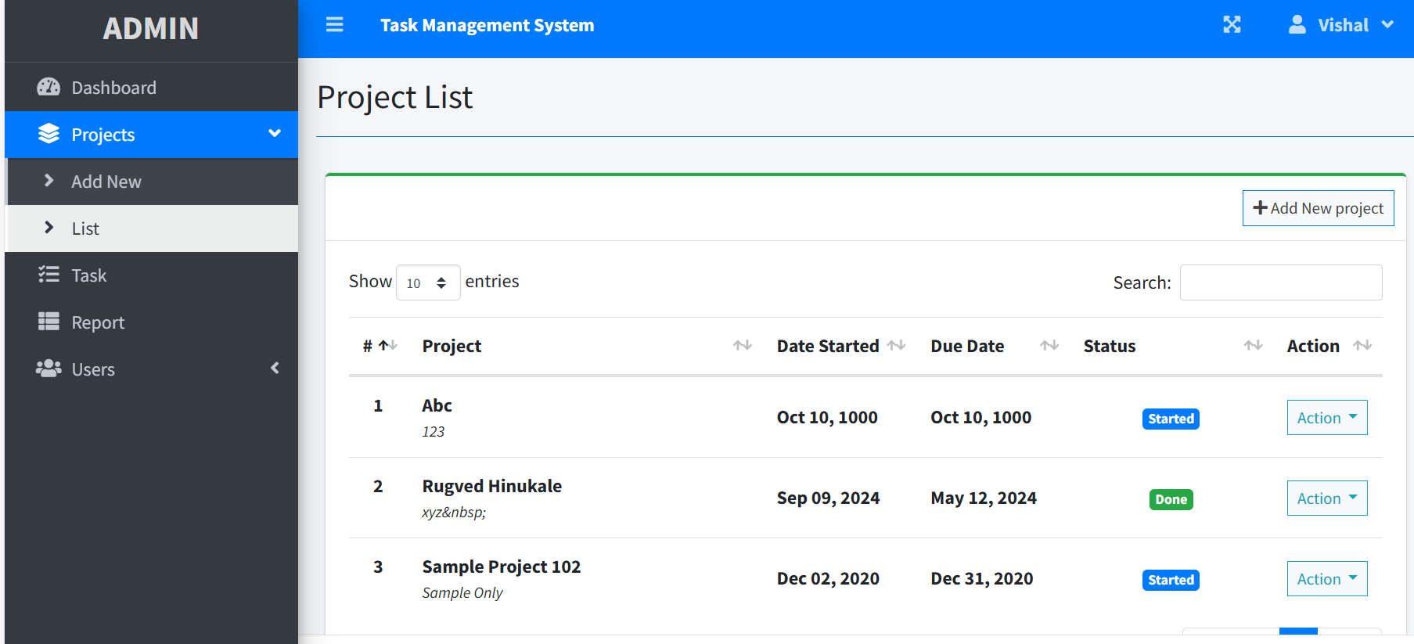

5.Pages for viewing the task list.

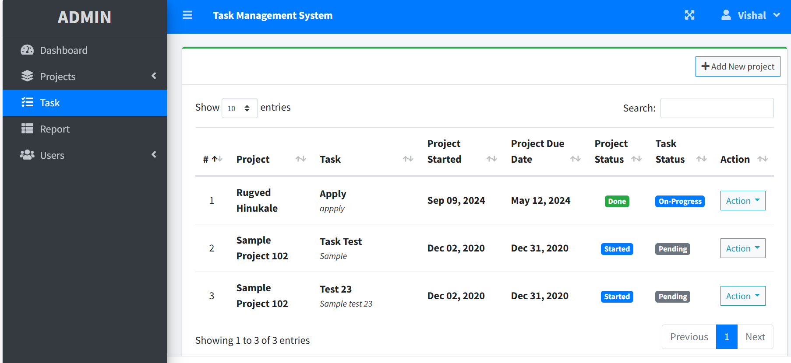

6.For assigning the new tasks to the team members under project.

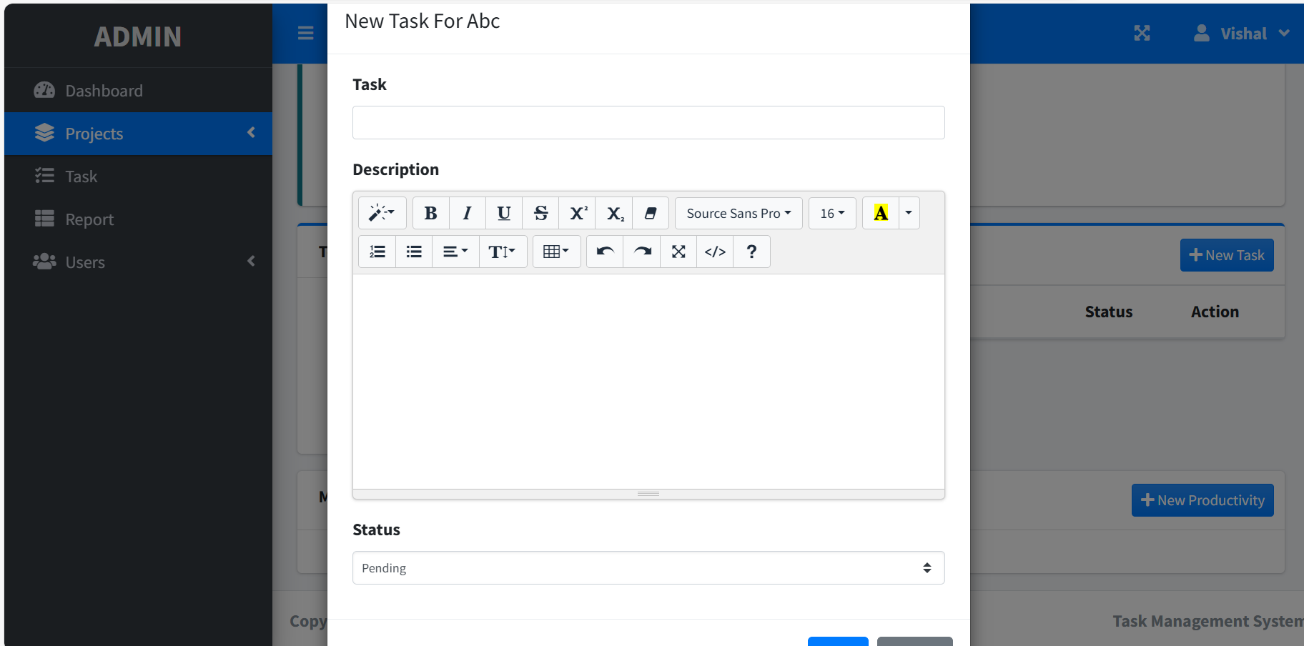

7.For Viewing the reports about the tasks and project.

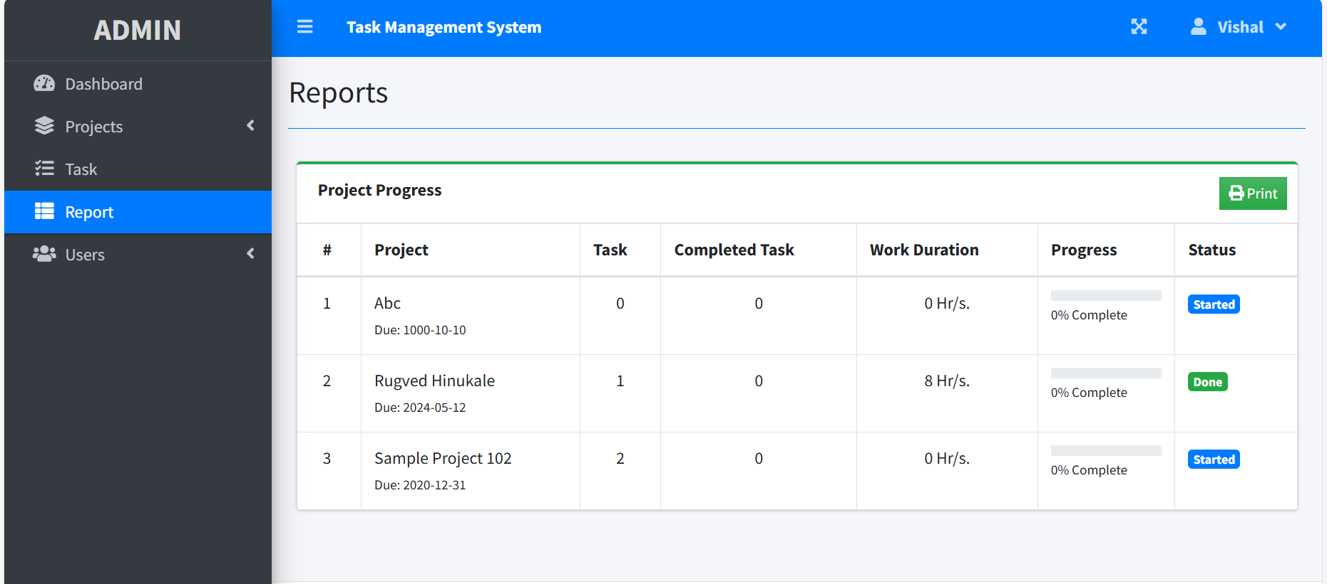

8.For adding the new employee according to their designation.

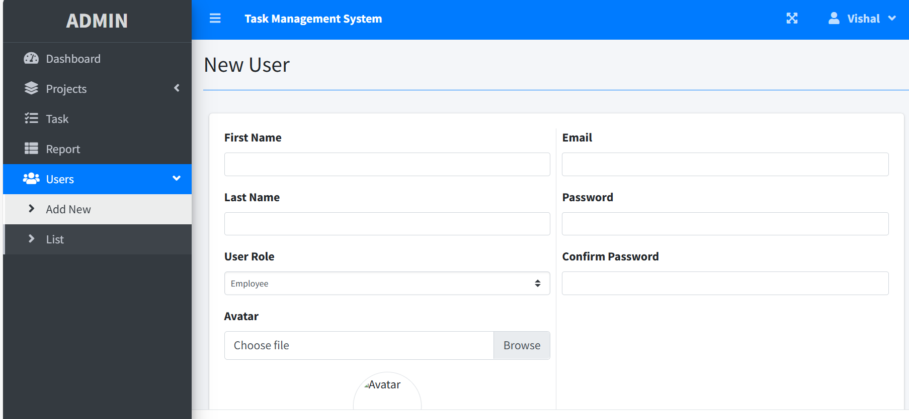

9.Page for viewing the employees lists.

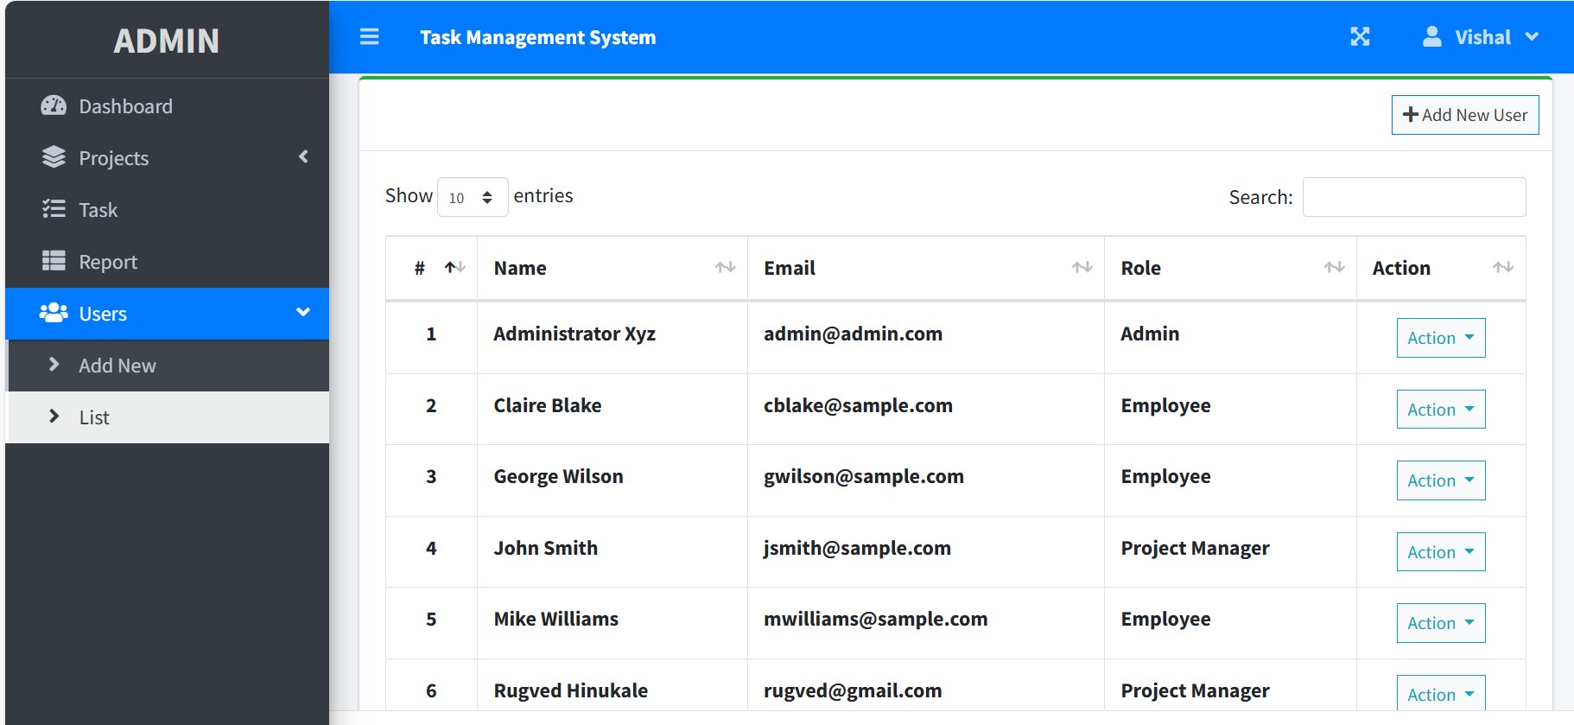

10.The page of manage account.

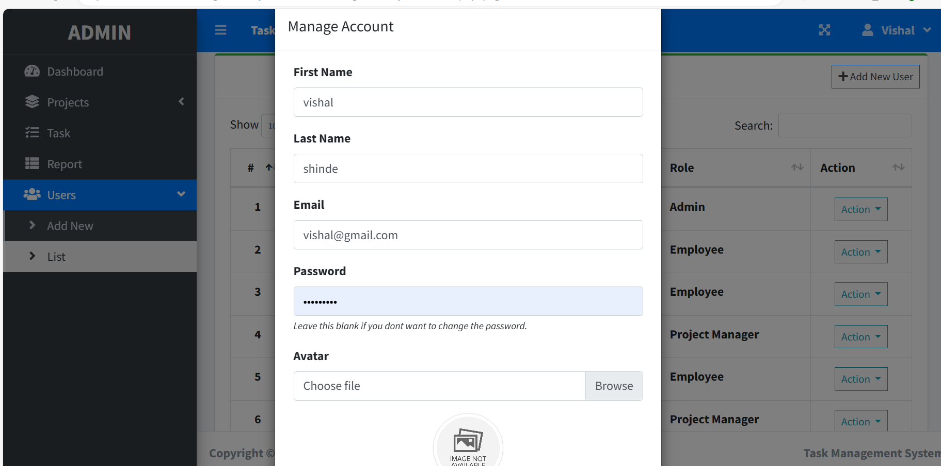

11. Reset password If any employee or admin forget their password.

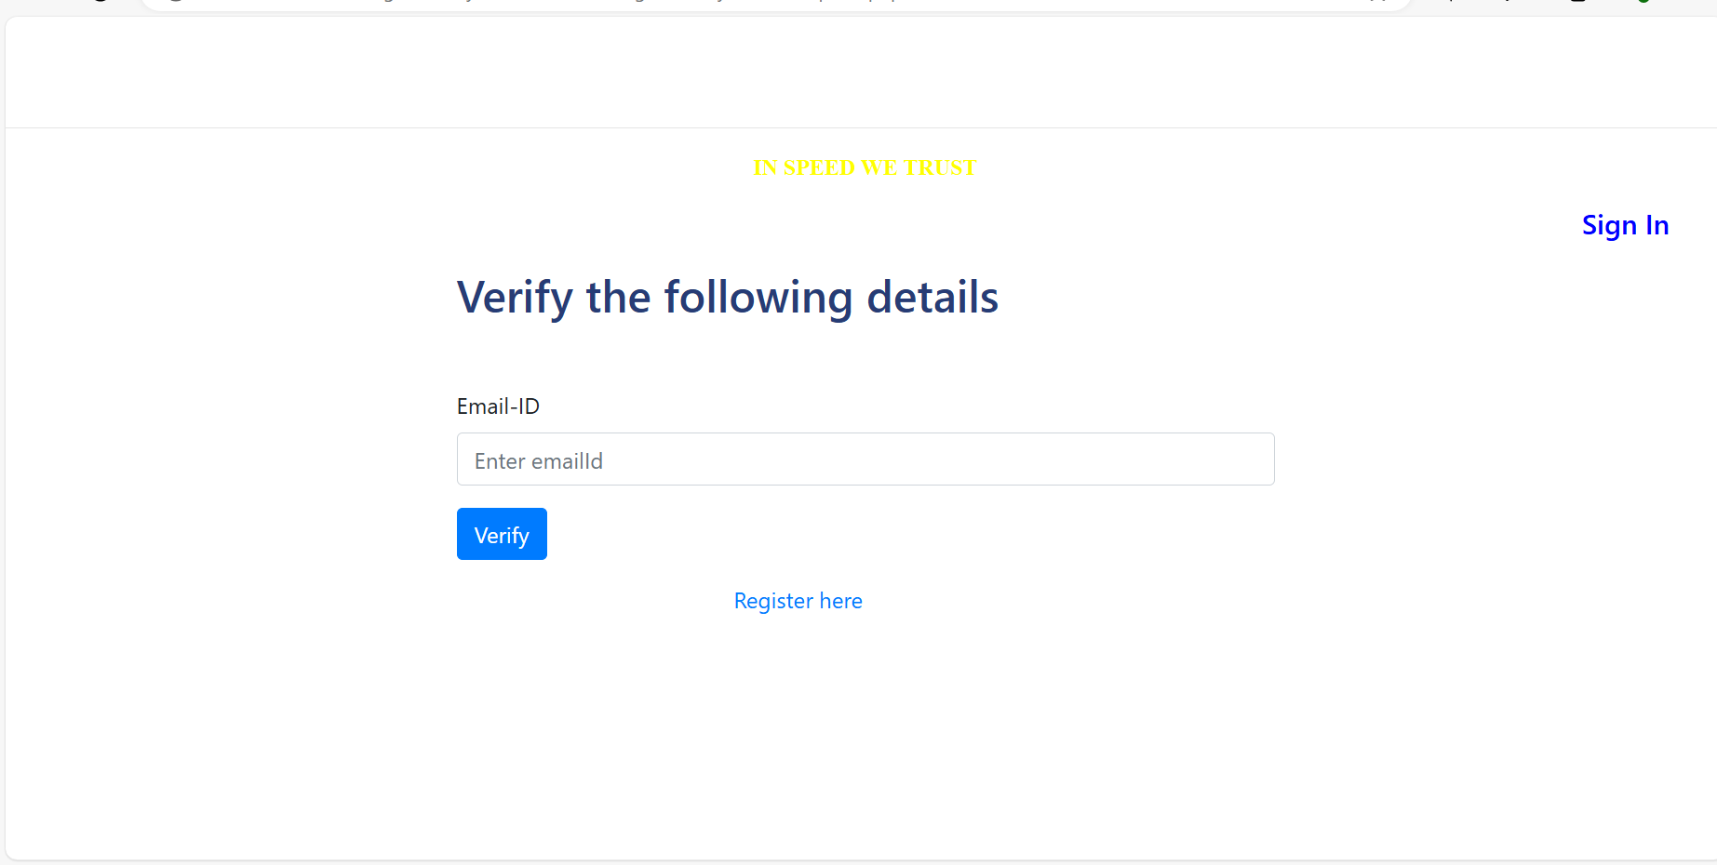

12. Employee login page

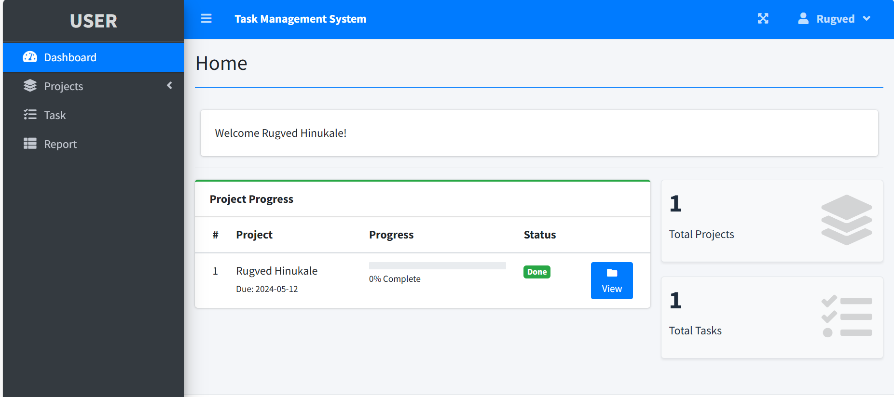

**5. VALIDATION CODE**

**1.Validation part in login page for Email-id and Password:**

**<?php**

**if(isset($_SESSION['login_id']))**

**header("location:index.php?page=home");**

**?>**

**<?php include 'header.php' ?>**

**<body class="hold-transition login-page bg-black">**

**<div class="login-box">**

**<div class="login-logo">**

**<a href="#" class="text-white"><b><?php echo $_SESSION['system']['name'] ?> - Admin</b></a>**

**</div>**

**<!-- /.login-logo -->**

**<div class="card">**

**<div class="card-body login-card-body">**

**<form action="" id="login-form">**

**<div class="input-group mb-3">**

**<input type="email" class="form-control" name="email" required placeholder="Email">**

**<div class="input-group-append">**

**<div class="input-group-text">**

**<span class="fas fa-envelope"></span>**

**</div>**

**</div>**

**</div>**

**<div class="input-group mb-3">**

**<input type="password" class="form-control" name="password" required placeholder="Password">**

**<div class="input-group-append">**

**<div class="input-group-text">**

**<span class="fas fa-lock"></span>**

**</div>**

**</div>**

**</div>**

**<div class="row">**

**<div class="col-8">**

**<div class="icheck-primary">**

**<input type="checkbox" id="remember">**

**<label for="remember">**

**Remember Me**

**</label>**

**</div>**

**</div>**

**<!-- /.col -->**

**<div class="col-4">**

**<button type="submit" class="btn btn-primary btn-block">Sign In</button>**

**</div>**

**<!-- /.col -->**

**</div>**

**</form>**

**<form action="resetpswd.php" method="get">**

**<div class="form-group">**

**<button type="submit" class="btn btn-danger">Reset Password</button>**

**</div>**

**</form>**

**</div>**

**<!-- /.login-card-body -->**

**</div>**

**</div>**

**<!-- /.login-box -->**

**<script>**

**$(document).ready(function(){**

**$('#login-form').submit(function(e){**

**e.preventDefault()**

**start_load()**

**if($(this).find('.alert-danger').length > 0 )**

**$(this).find('.alert-danger').remove();**

**$.ajax({**

**url:'ajax.php?action=login',**

**method:'POST',**

**data:$(this).serialize(),**

**error:err=>{**

**console.log(err)**

**end_load();**

**},**

**success:function(resp){**

**if(resp == 1){**

**location.href ='index.php?page=home';**

**}else{**

**$('#login-form').prepend('<div class="alert alert-danger">Username or password is incorrect.</div>')**

**end_load();**

**}**

**}**

**})**

**})**

**})**

**</script>**

**<?php include 'footer.php' ?>**

**</body>**

**</html>**

**6.FUTURE ENHANCEMENT**

* For any system that is developing, there is always way for more development.
* The Task management System has a lot of enhancement options.
* Some of future enhancement we can do in future version are as follows :

1. In future more features may be added category-wise.
2. Can also add option so that employee can directly mark an attendance using management system.
3. Can also add option tracking the status of project of status automatically.

**7.CONCLUSION**

* It has user-friendly interface so user can use system easily with the basic knowledge of computer.
* This software will help admin for storing data easily.
* Proper testing has been done by developer.
* This software is secure as it has proper authentication system .
* It can keep all your data stored for a long duration.
* It will give you all the data when you need it within some time.

**8.REFERENCES AND BIBLIOGRAPHY**

* [**www.google.com**](http://www.google.com)
* [**www.youtube.com**](http://www.youtube.com)